Problem #1

a) Plot a histogram and boxplot

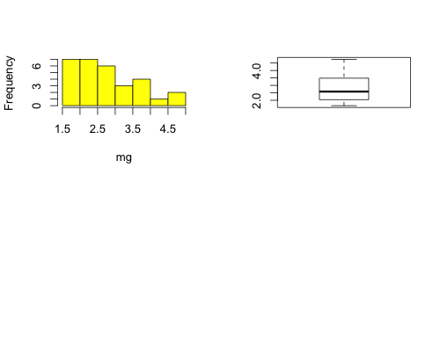

b)

skewness = 0.686

kurtosis = 2.27

c)

Please refer to the code

d)

mean = 2.706

median = 2.585

variance = 0.800

standard deviation = 0.894

coefficient of variation = 0.331

Problem #2

Probability of obtaining 5 or fewer heads = P(X<=5) = 0.02

Probability of obtaining more than 5 heads = P(X>5) = 0.98

Problem #3

The probability of getting one answer right is 1/4 = 0.25

So, the probability of getting 17 or more correctly out of 20 random guesses is:

1 – P(n<=16) = 1- pbinom(16, 20, 0.25) = 0.00000002960496

Problem #4

Probability of having 9 or more butterflies = 0.0213

Problem #5

Probability of counting exact 4 species = 0.00001374102

Probability of counting 15 or more = 0.8951357

Probability distribution:

